**Bug Report - QA Railway Website**

**Bug ID: 001**

**Test Case ID:** TC03

**Summary:**

User cannot log into Railway website using a valid email and invalid password.

**Description:**

When the user enters a valid email and an invalid password on the QA Railway Website, the system displays an unexpected error message. The message shown does not match the expected message for an invalid login attempt.

**Steps to reproduce:**

1. Navigate to QA Railway Website
2. Click on the **"Login"** tab
3. Enter a **valid email** and an **invalid password**
4. Click the **"Login"** button

**Observed/Actual Result:**

The system displays the message:

**“Invalid username or password. Please try again.”**

**Expected Result:**

The system should display the message:

**“There was a problem with your login and/or errors exist in your form.”**

**Screenshot:**

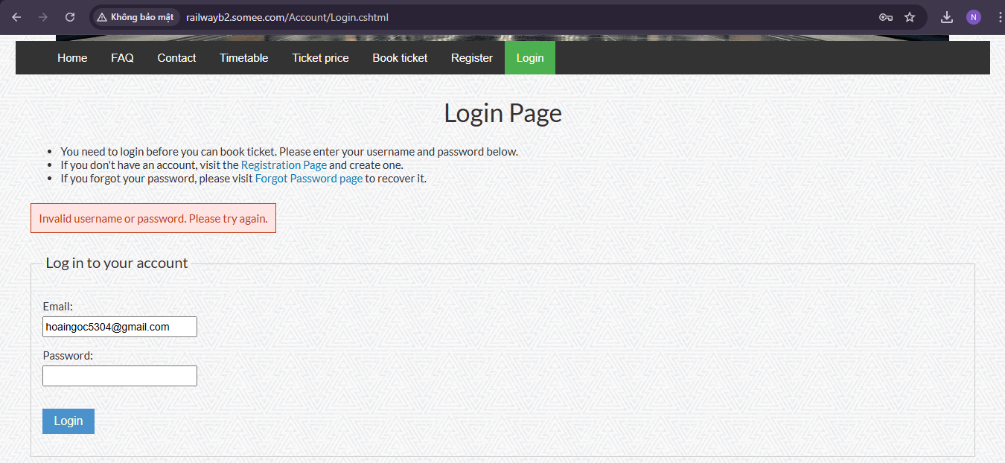

**Bug ID: 002**

**Test Case ID:** TC03

**Summary:**

System does not show proper warning message after multiple failed login attempts.

**Description:**

When the user repeatedly enters a valid email and an invalid password on the QA Railway Website, the system continues to display a generic invalid login message. It does not show the appropriate warning message that indicates the number of failed login attempts or the upcoming lockout.

**Steps to reproduce:**

1. Navigate to QA Railway Website
2. Click on **"Login"** tab
3. Enter a **valid email** and an **invalid password**
4. Click the **"Login"** button
5. Repeat steps 3 and 4 three more times (total of 4 failed attempts)

**Observed/Actual Result:**

The system displays the message:

**“Invalid username or password. Please try again.”**

**Expected Result:**

The system should display the message: **“You have used 4 out of 5 login attempts. After all 5 have been used, you will be unable to login for 15 minutes.”**

**Screenshot:**

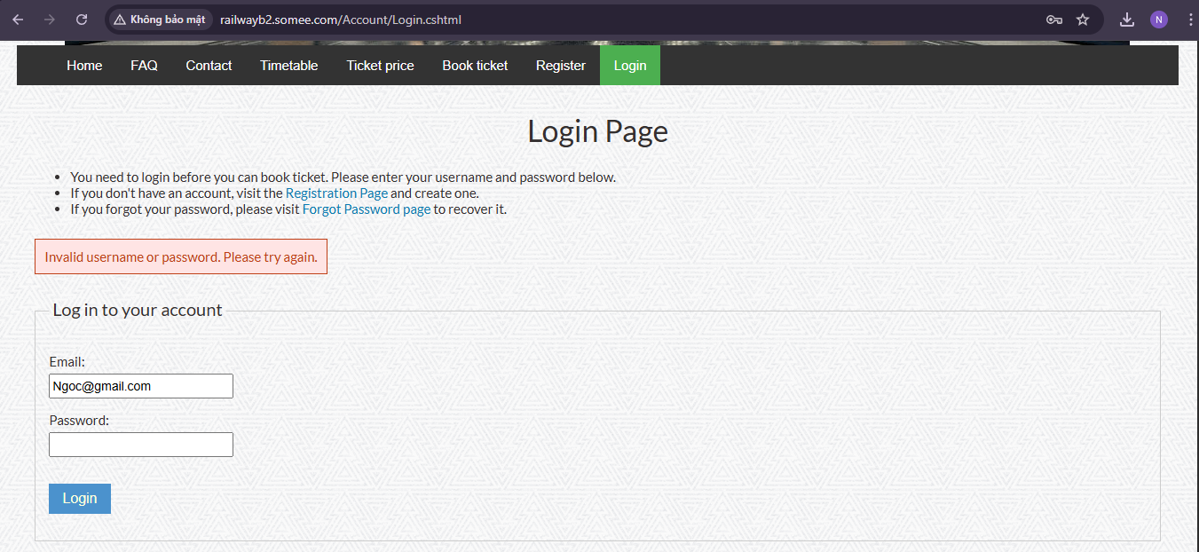

**Bug ID: 003**

**Test Case ID:** TC07

**Summary:**

Incorrect success message displays after creating a new account.

**Description:**

When the user registers a new account with valid information, the expected success message should be **"Thank you for registering your account"**. However, the system displays **"You're here"** instead, which is not appropriate and does not confirm the action clearly.

**Steps to reproduce:**

1. Navigate to QA Railway Website
2. Click on **"Register"** tab
3. Enter **valid information** into **all fields**
4. Click on **"Register"** button

**Observed/Actual Result:**

The system displays the message:

**“You're here”**

**Expected Result:**

The system should display the message:

**“Thank you for registering your account”**.

**Screenshot:**

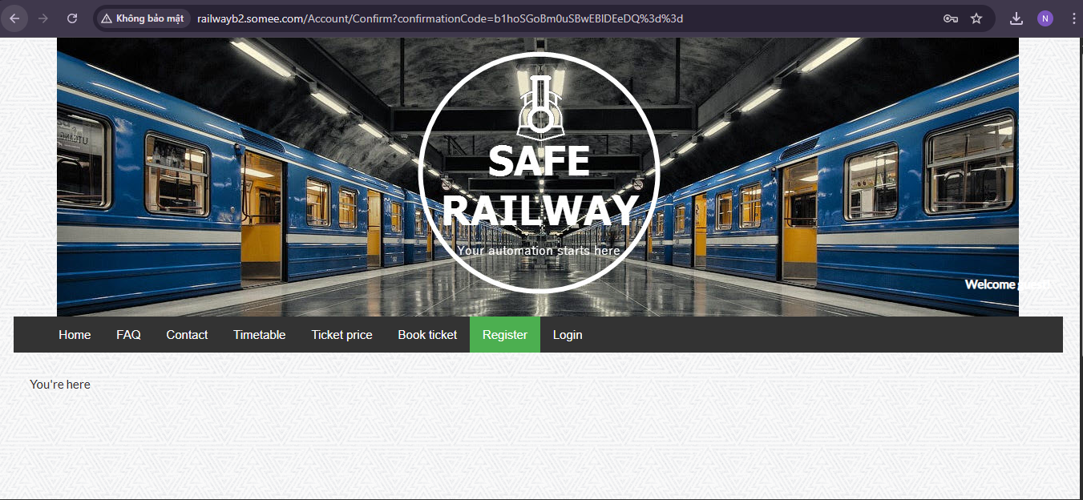

**Bug ID: 004**

**Test Case ID:** TC09

**Summary:**

Incorrect success message format – missing exclamation mark after changing password

**Description:**

When the user changes their password, the message **"Your password has been updated"** appears. However, it is missing an exclamation mark at the end, which results in an incorrect message format.

**Steps to reproduce:**

1. Navigate to QA Railway Website
2. Login with **valid account**
3. Click on **"Change Password"** tab
4. Enter valid value into all fields.
5. Click on **"Change Password"** button

**Observed/Actual Result:**

The system displays the message:

**“Your password has been updated”**

**Expected Result:**

The system should display the message:

**“Your password has been updated!”**

**Screenshot:**

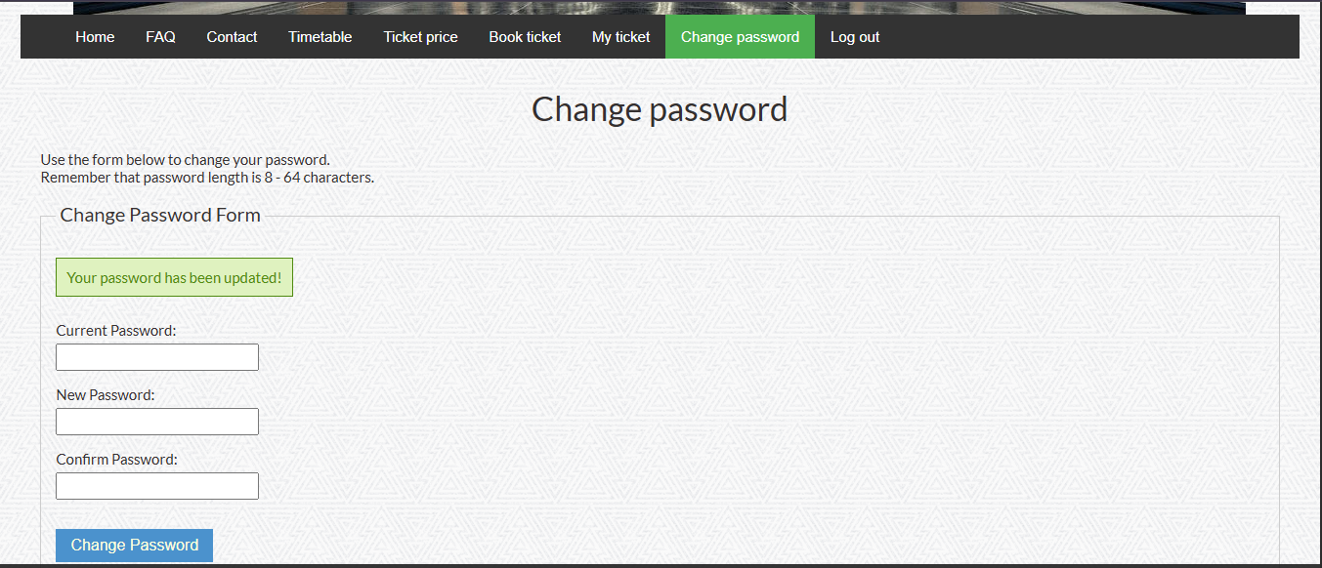

**Bug ID: 005**

**Test Case ID:** TC11

**Summary:**

User cannot create an account when the password and PID fields are empty

**Description:**

When the user attempts to create an account with **only a valid email address** and leaves **the** **password and PID fields empty**, an error message displays correctly above the form. However, the error messages next to the password and PID fields are missing periods at the end.

**Steps to reproduce:**

1. Navigate to the QA Railway website.
2. Click on the **"Register"** tab.
3. Enter **a valid email address** and leave **the password and PID fields empty.**
4. Click on the **"Register"** button.

**Observed/Actual Result:**

The message **“There're errors in the form. Please correct the errors and try again.”** displays correctly above the form.

Next to the password field, the error message **“Invalid password length”** displays (missing period).

Next to the PID field, the error message **“Invalid ID length”** displays (missing period).

**Expected Result:**

The system should display the error messages with periods at the end, specifically **“Invalid password length.”** and **“Invalid ID length.”**

**Screenshot:**

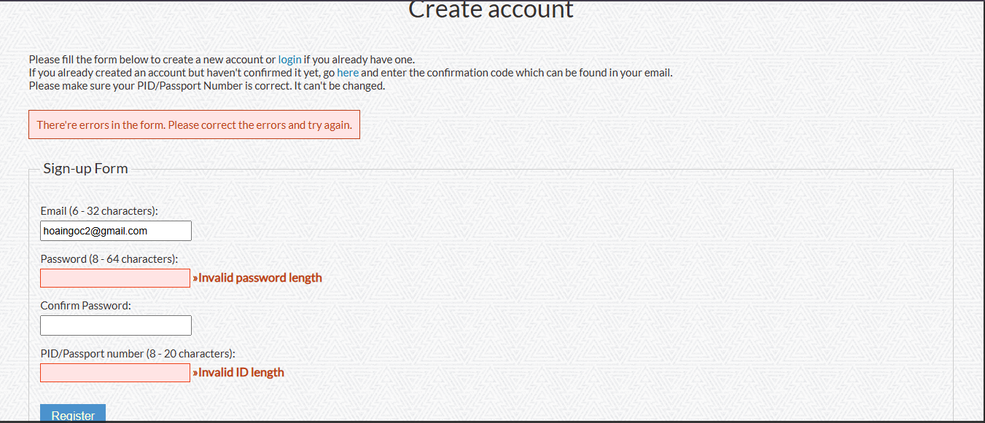

**Bug ID: 006**

**Test Case ID:** TC12

**Summary:**

Server error prevents testing empty reset token behavior

**Description:**

When clicking **"Send Instructions"** for password reset, the system encounters a server error related to SMTP. The error message indicates that the SMTP username is not allowed to send emails.This prevents the user from proceeding to the next step to reset the password.

**Steps to reproduce:**

1. Navigate to QA Railway Login page.
2. Click on the **"Forgot Password"** link.
3. Enter the email address of the created account.
4. Click on **"Send Instructions"** button.

**Observed/Actual Result:**

The following error occurs:

**“Server Error in '/' Application.**

**Mailbox unavailable. The server response was: that smtp username is not allowed to send. ”**

**Impact:** The system fails to send the password reset email, stopping the user from proceeding to reset their password.

**Expected Result:**

The system should successfully send the password reset email, allowing the user to proceed to the **"Password Change Form"** page. If the password reset token is left blank, the system should display the following error message above the form:**"The password reset token is incorrect or may be expired. Visit the forgot password page to generate a new one."**

Additionally, an error message should appear next to the **"Password Reset Token"** field:**"The password reset token is invalid."**

**Screenshot:**

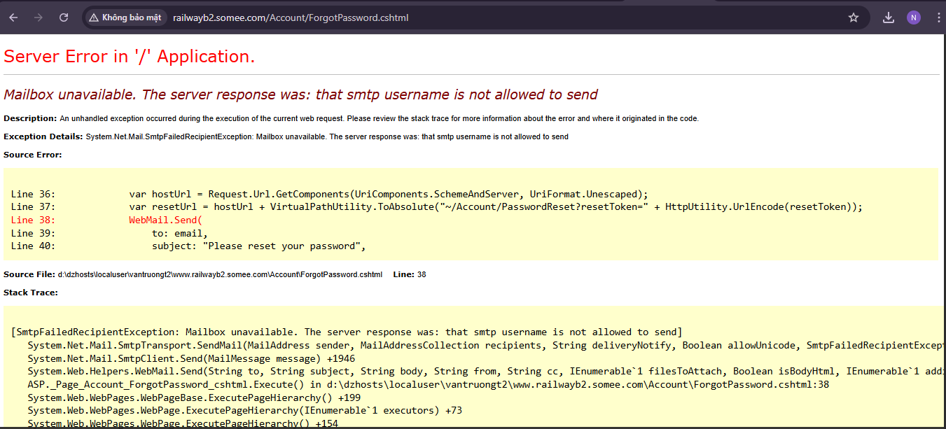

**Bug ID: 007**

**Test Case ID:** TC13

**Summary:**

Server error prevents testing mismatched password confirmation

**Description:**

When attempting to reset the password, the system fails to send the reset email and displays a **"Server Error"** message due to SMTP issues. The error details show that the SMTP username is not allowed to send emails.

**Steps to reproduce:**

1. Navigate to QA Railway Login page.
2. Click on the **"Forgot Password"** link.
3. Enter the email address of the created account.
4. Click on **"Send Instructions"** button.

**Observed/Actual Result:**

The following error occurs:

**“Server Error in '/' Application.**

**Mailbox unavailable. The server response was: that smtp username is not allowed to send.”**

**Impact:** The system fails to send the password reset email, stopping the user from proceeding to reset their password.

**Expected Result:**

The system should successfully send the password reset email, allowing the user to proceed to the **"Password Change Form"** page. If the password and confirm password fields do not match, the system should display the following error message above the form:**"Could not reset password. Please correct the errors and try again."**

Additionally, an error message should appear next to the **"Confirm Password"** field:

**"The password confirmation did not match the new password."**

**Screenshot:**

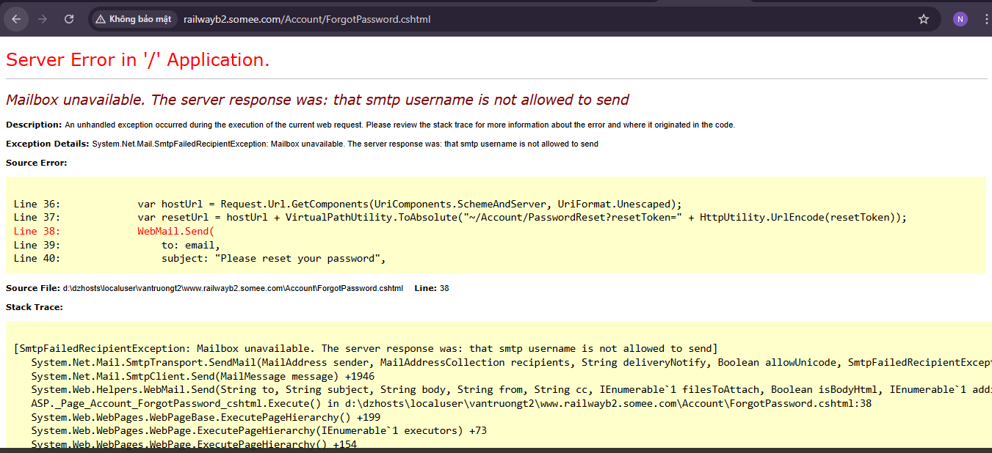

**Bug ID: 008**

**Test Case ID:** TC14

**Summary:**

**"Ticket Booked Successfully!"** message formatting issue

**Description:**

The system displays the confirmation message in an inconsistent format. Instead of **"Ticket Booked Successfully!"**, it shows **"Ticket booked successfully!"** with incorrect capitalization.

**Steps to reproduce:**

1. Create and activate a new account.
2. Navigate to QA Railway Website.
3. Login with **a valid account.**
4. Click on **"Book ticket"** tab.
5. Select **"Depart date"**.
6. Select"Sài Gòn" for **"Depart from"** and "Nha Trang" for **"Arrive at"**.
7. Select "Soft bed with air conditioner" for **"Seat type"**.
8. Select "1" for **"Ticket amount"**.
9. Click on **"Book ticket"** button.

**Observed/Actual Result:**

The message **"Ticket booked successfully!"** is displayed, but with incorrect capitalization (**"Ticket booked successfully!"** instead of **"Ticket Booked Successfully!"**).

**Expected Result:**

The message should be displayed as **"Ticket Booked Successfully!"** with proper capitalization.

**Screenshot:**

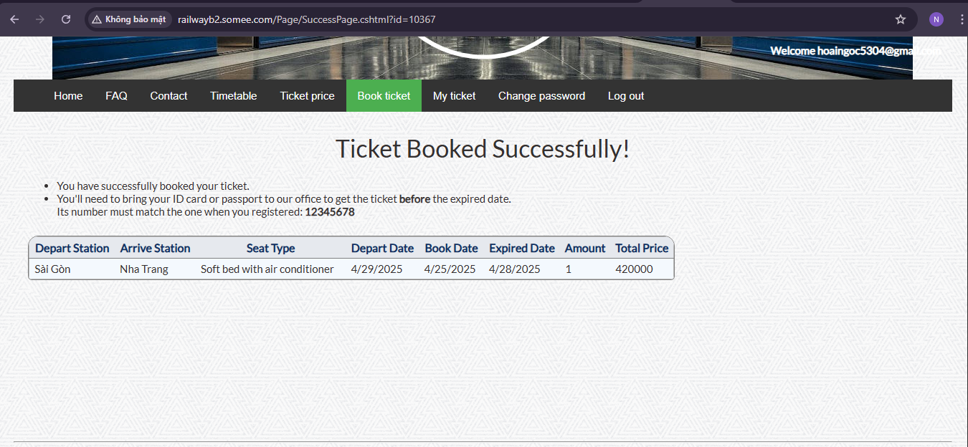

**Test Case ID:** TC08

**Đặt câu hỏi:**

Dear Ms. My,

I have a question regarding Test Case TC08: "User can't login with an account that hasn't been activated."

According to the test steps, I should create a new account without activating it, then try to log in and verify that the system prevents login for inactive accounts.

However, on the actual website (http://railwayb2.somee.com), the system does not send any activation email after registration. This means I cannot reproduce the "inactive account" state as described in the test case.

As a result, I'm unsure how to properly execute this test. I'm considering two possible approaches:

Logging in with a newly registered account (even though there's no activation process) to see if the system allows access – however, I've already done this in Test Case 01.

Intentionally entering incorrect login credentials to verify the error message – but this has already been covered in Test Case 03.

Could you please clarify how I should proceed with Test Case 08 given the current limitations of the system? I’d like to ensure I'm following the intended testing approach and not duplicating what has already been tested.

Thank you in advance for your guidance.